

#### **Uploading and Downloading file**

**to Azure File storage in NAV 2016**



1. **Create Azure Blob Storage**

The section contains the guidelines on how to Create Azure Blob Storage.

* Open [Portal.Azure.com](https://login.microsoftonline.com/common/oauth2/authorize?resource=https%3a%2f%2fmanagement.core.windows.net%2f&response_mode=form_post&response_type=code+id_token&scope=user_impersonation+openid&state=OpenIdConnect.AuthenticationProperties%3dZmNLpG5-PQSMJvfKiX_jeFiJyS9i2AF7oI6t0nItXDggUavm971toIAvZYq0EsH5PZCib5Jz_e74XpCP7ySFSsd7Ic5lo5u8iR-uGecFJlRg9V-T86z3124uwDCLXBxsPrc0F0tszG8xn_f2HFXTKMmVsdXeRwA8xIaE9LFSMsAuzeyhVgWYthzJ-pJ1yUIsKvGGK07KuV1ncGKka8aCccAJDqpRrvxmk1dFmUs597w&nonce=636901293751289384.MmVkYjExZmUtOThiYS00NDYwLTg3YmYtZDk1NWUzOTVjNzNkZWUyOGU1MjEtNDY5Mi00MTRmLTk0ODktYzE3OTJhNzgwYjMz&client_id=c44b4083-3bb0-49c1-b47d-974e53cbdf3c&redirect_uri=https%3a%2f%2fportal.azure.com%2fsignin%2findex%2f&site_id=501430&client-request-id=76dec264-ff4f-49a5-840a-d4f11fe8dd17&x-client-SKU=ID_NET&x-client-ver=1.0.40306.1554).
* Navigate to Storage Account.

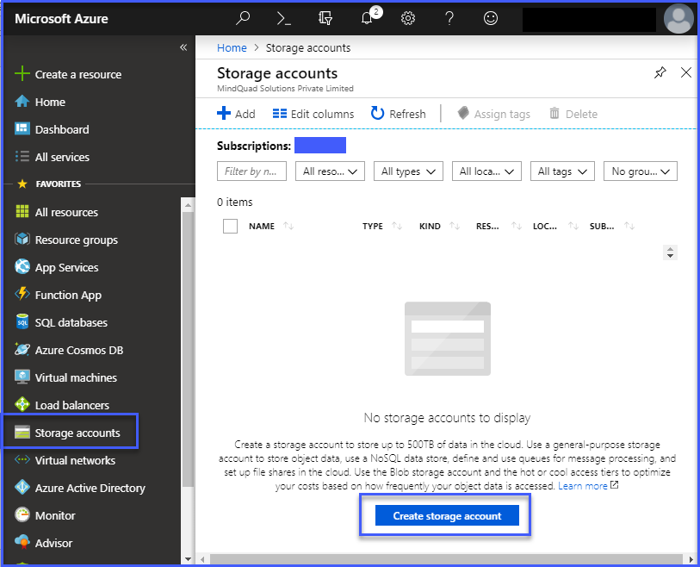

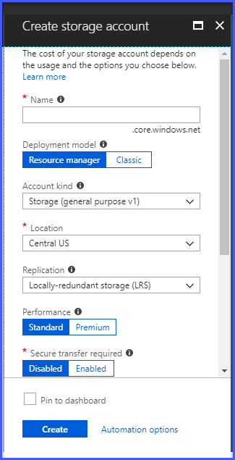

* Navigate to Blob Section as shown below

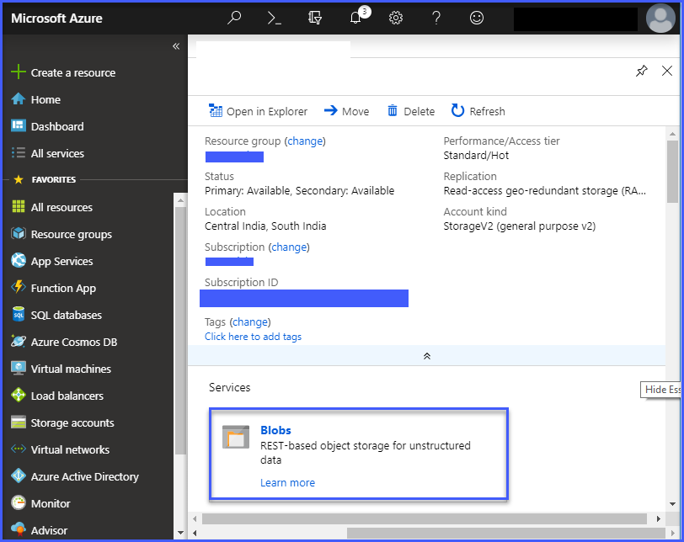

* Next Create Container for the Blob to Add files into the Container using Upload Button as shown below.

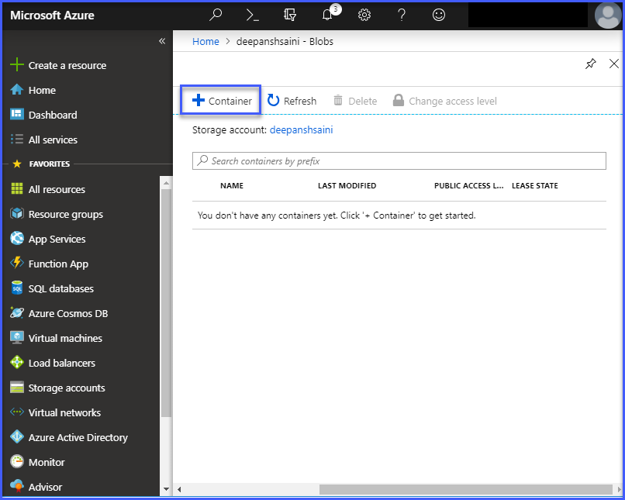

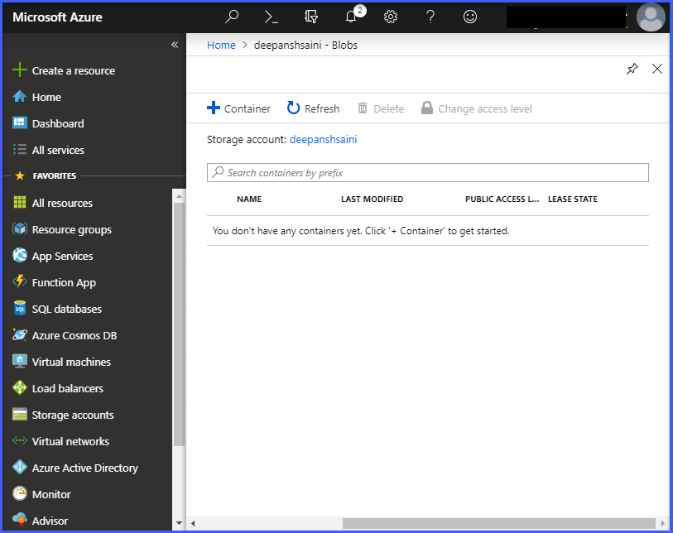

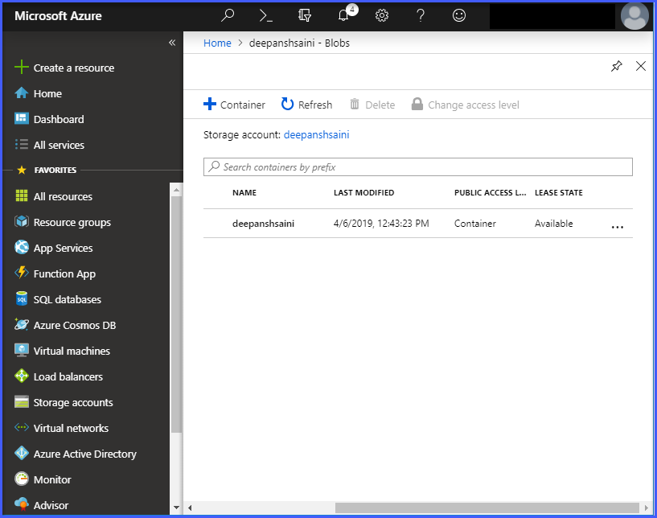

* Navigate to Storage Account (Which you created) -> Access Key , Copy Connection string which is used to connect Blob

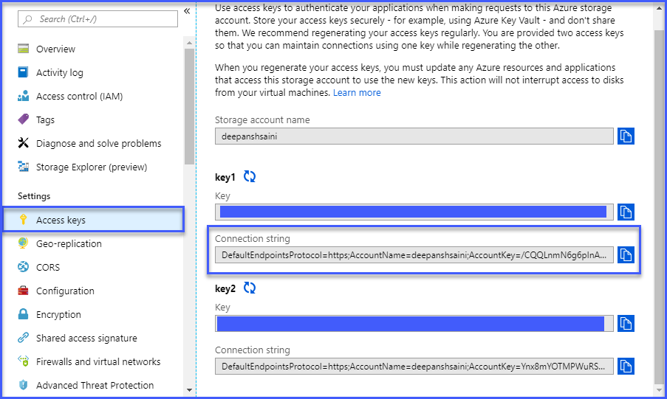

* **Copy all .dll files**

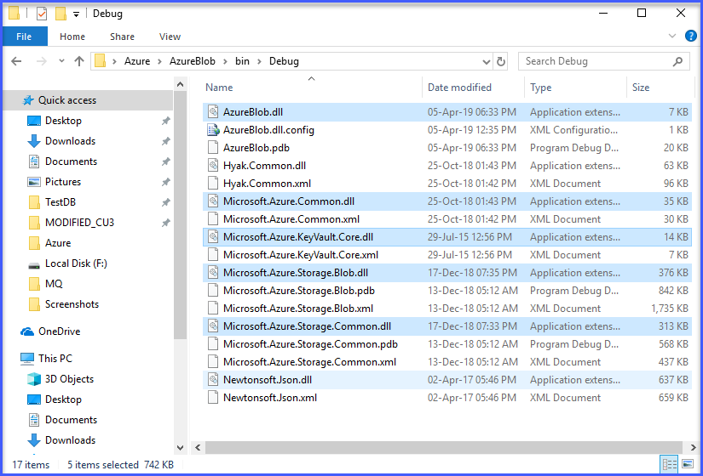

* **Go to Dynamics NAV catalog (look at this screenshot) and paste your files.**

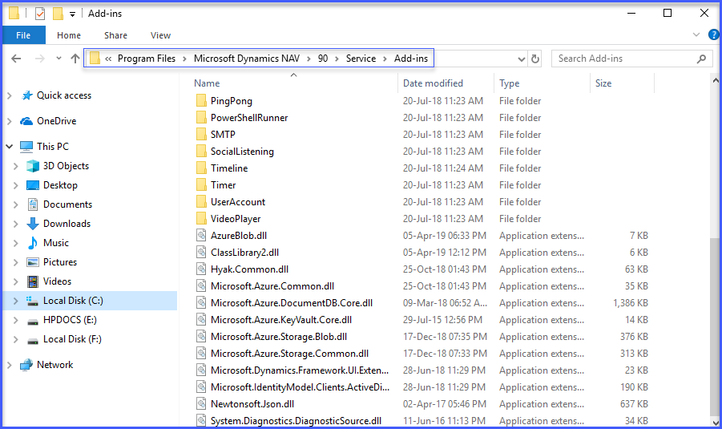

* **Fill all information related Azure Account in Company Information.**

**Account Name - <Enter Your Azure Blob Account Name>**

**Account Key - <Copy Key from your Azure Blob storage account key >**

**Container - <Enter your Container name >**

**Download Path - <Enter Download Path>**

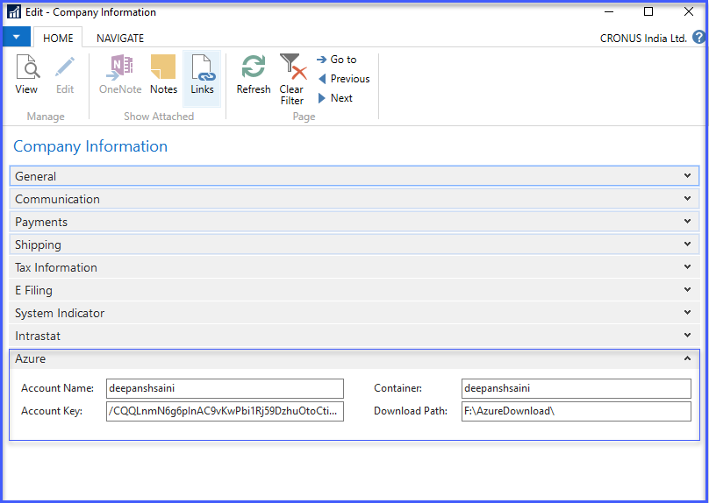

* **After that open Item List and in Azure Storage List fact box**
* **Click Action on “Upload to Azure “**
* **Choose a file for upload on azure storage**
* **After that click on open**

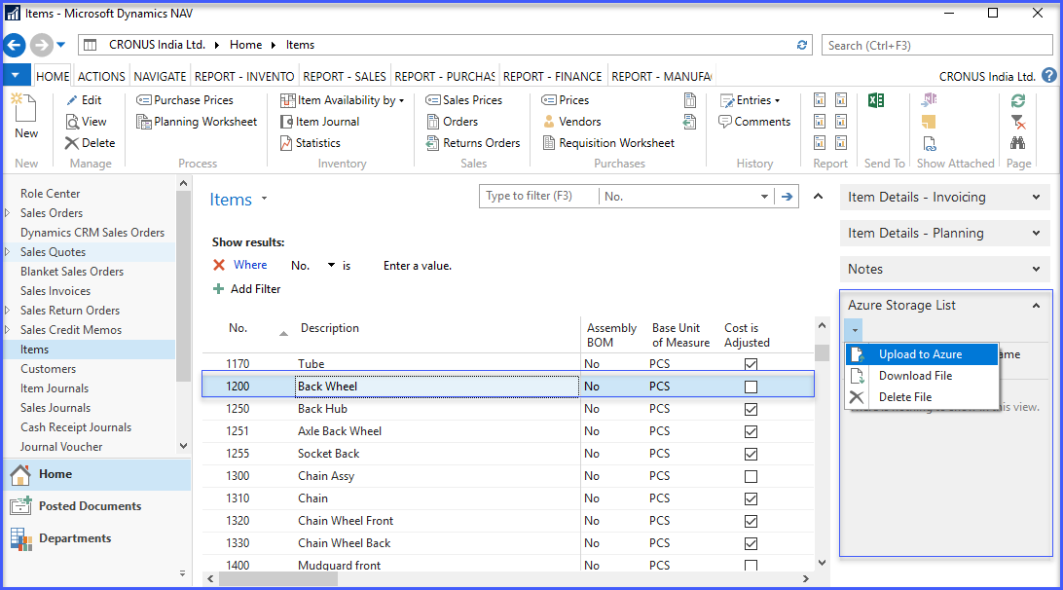

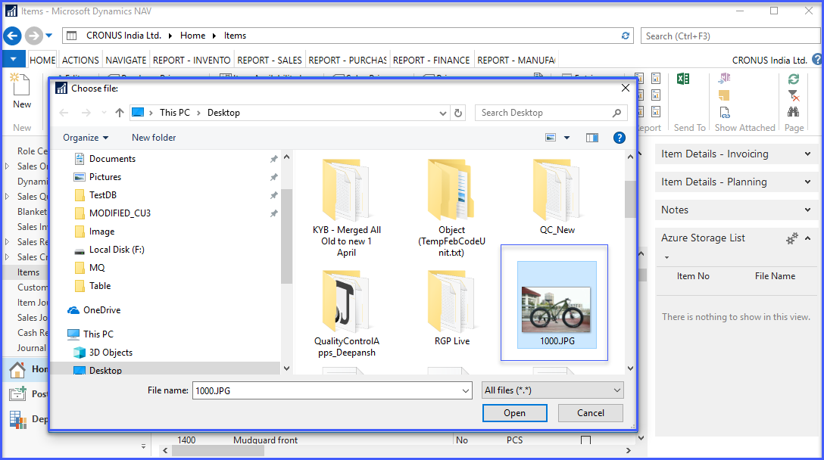

* **You can see this success Message. Your file successfully uploaded on your azure storage.**

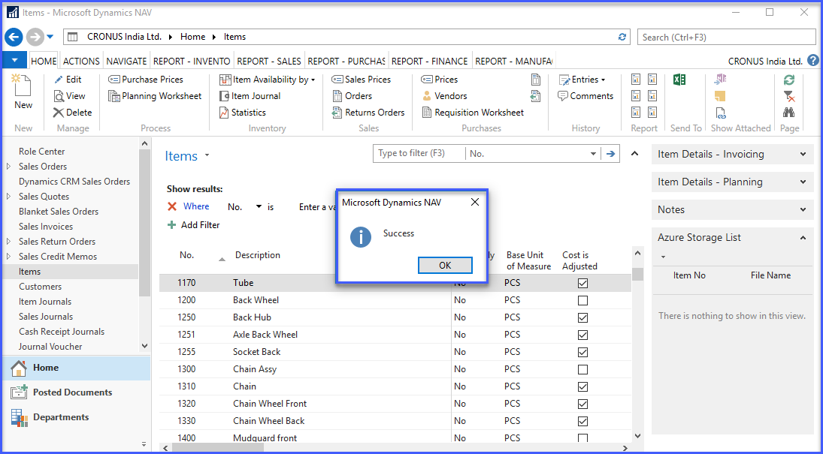

* **Selected file uploaded and attached with selected item in factbox.**

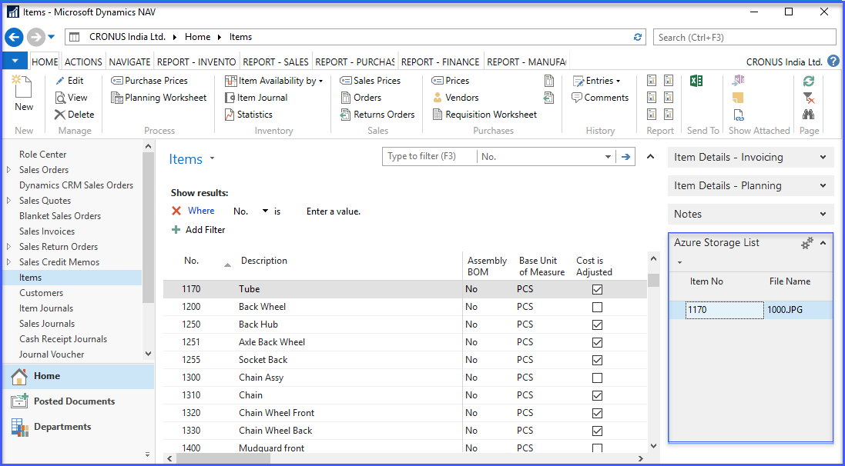

* **Now you can see in your azure storage account you find uploaded file**

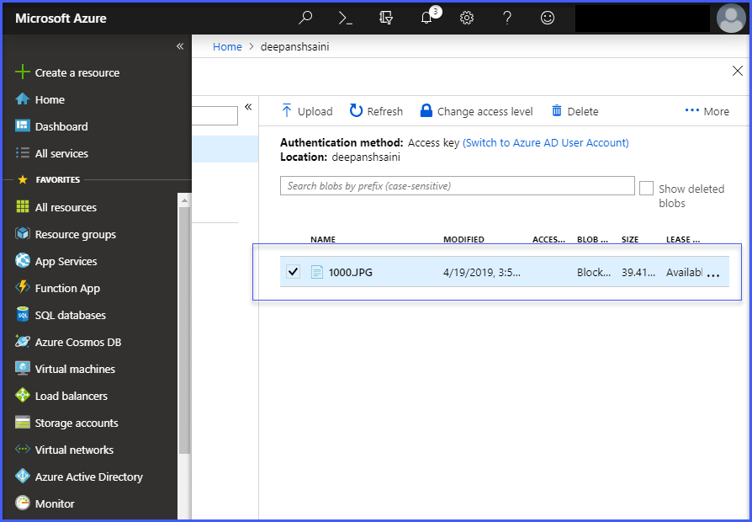

**Download File From Azure Blob**

* **Select a file in fact box and Click on “Download File “ Action**

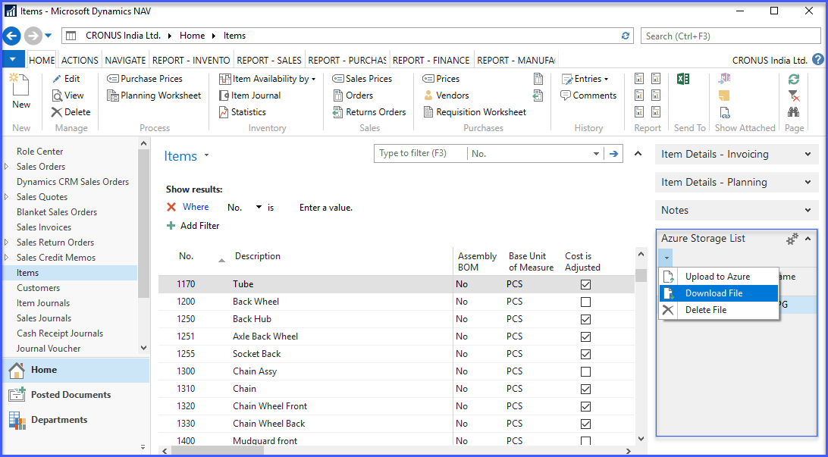

* **After click on Download File action you can see Open and Save Option.**

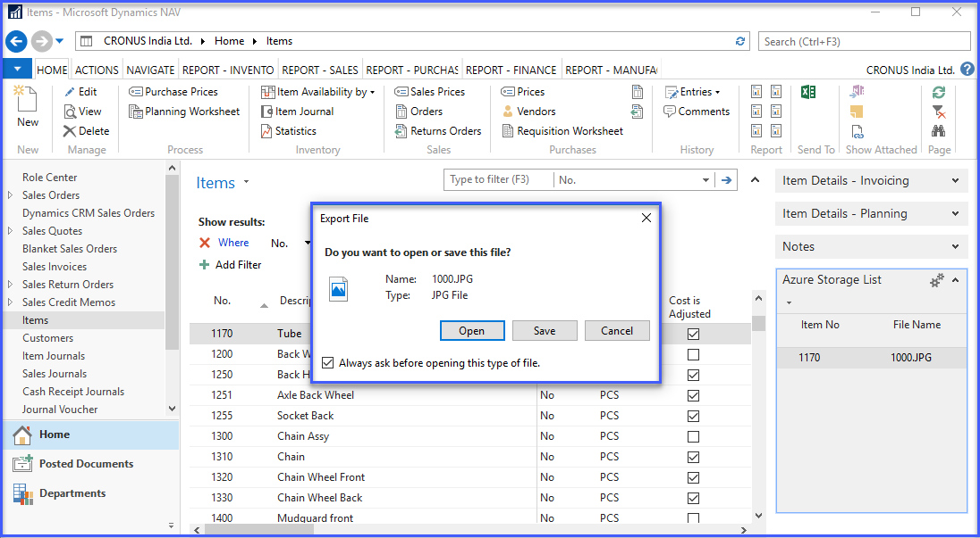

* **Click on Save Button and select location for save a file from Azure Storage.**

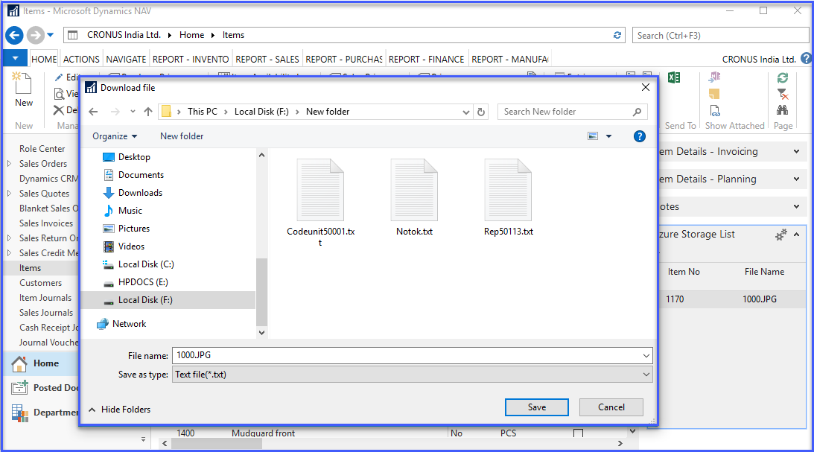

* **After that click on save button now you can see file.**

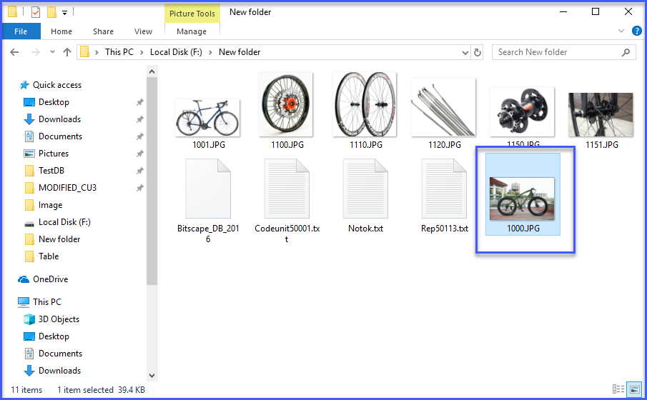

**Delete File from Azure Blob Storage**

* **Select a file you want to delete in factbox list**

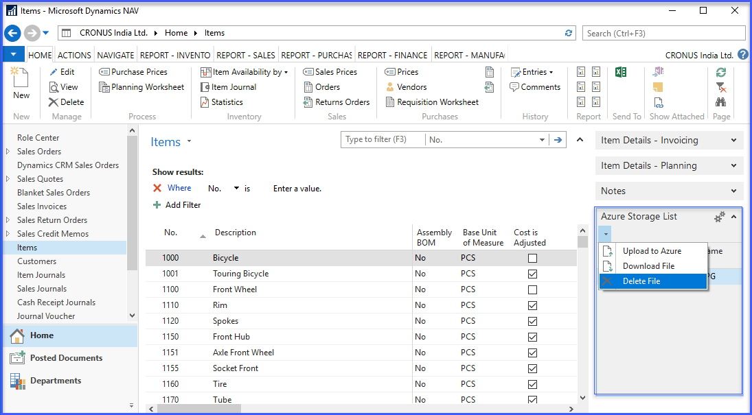

* **Click on “Delete File” Action**
* **Now you can see a Confirm Dialog with Yes and No option**

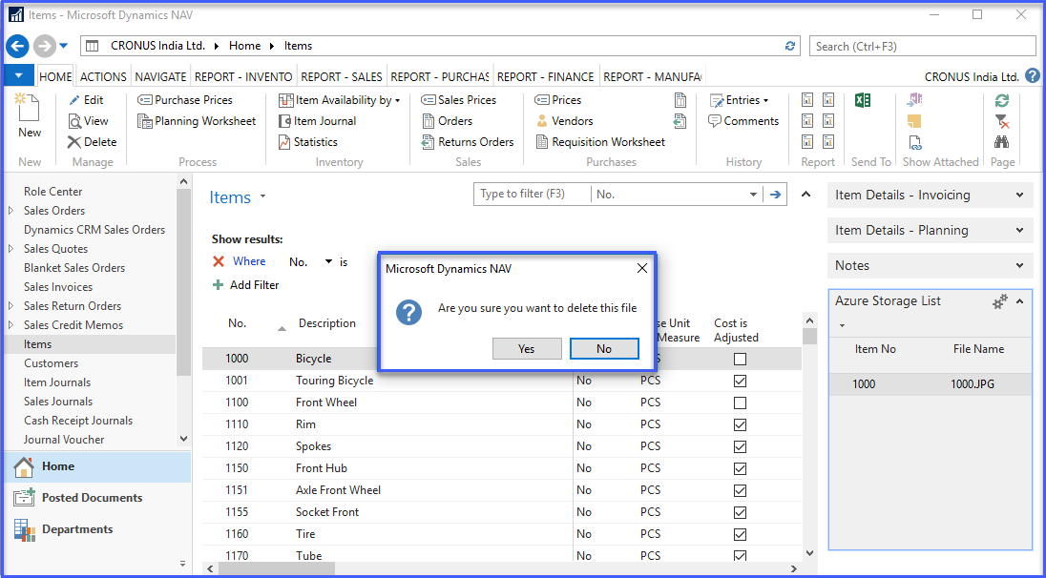

* **You can see this File Deleted Successfully Message. Your file successfully Deleted in your azure storage.**

